SETUP INGRESS-NGINX in DOCKER DESKTOP:

$ kubectl apply -f <https://raw.githubusercontent.com/kubernetes/ingress-nginx/controller-v0.44.0/deploy/static/provider/cloud/deploy.yaml>

$ kubectl get pods -n ingress-nginx

don’t fprget to set pgpassword:

$kubectl create secret generic pgpassword --from-literal=PGPASSWORD="postgrespassword"

open in tew terminal to start kubernetesdashboard

$kubectl proxy

open web browser to kubernetes dashboard:

<http://localhost:8001/api/v1/namespaces/kubernetes-dashboard/services/https:kubernetes-dashboard:/proxy/>.

CREATE INGRESS CONFIG FILE

# to define different sets of routing rules inside our application:

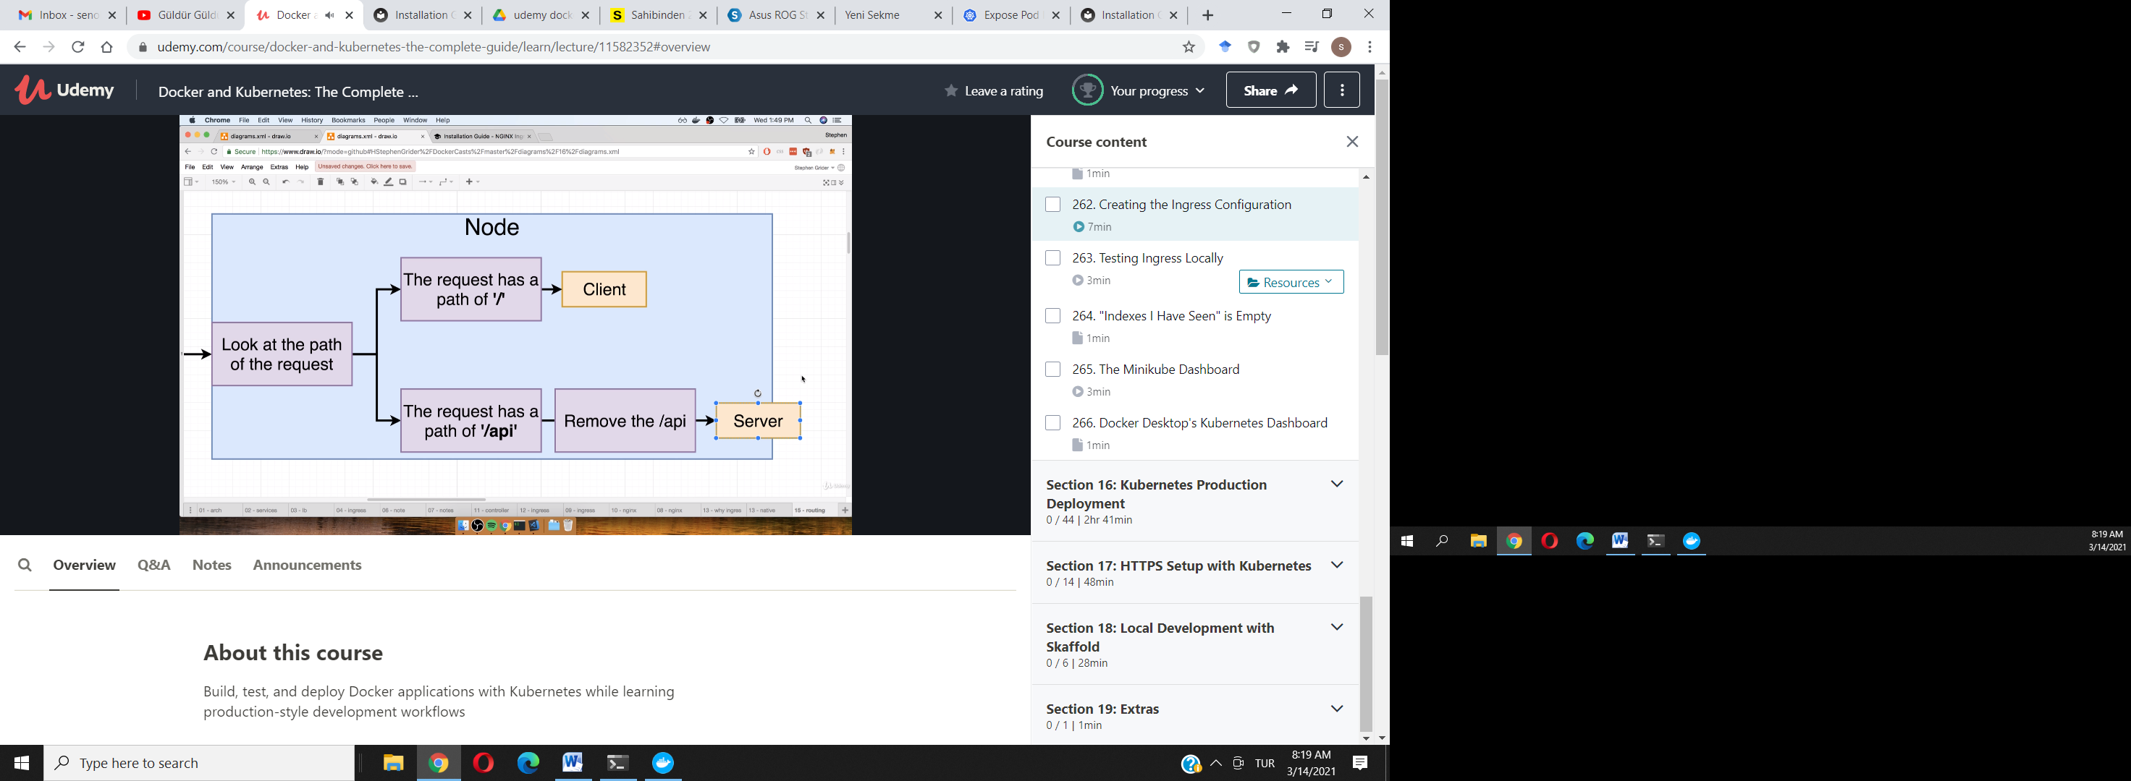

ingress-service.yaml:

apiVersion: networking.k8s.io/v1beta1

kind: Ingress

metadata:

name: ingress-service

annotations:

kubernetes.io/ingress.class: 'nginx'

nginx.ingress.kubernetes.io/use-regex: 'true'

nginx.ingress.kubernetes.io/rewrite-target: /$1

# UPDATE THIS LINE ABOVE

spec:

rules:

- http:

paths:

- path: /?(.*)

# UPDATE THIS LINE ABOVE

backend:

serviceName: client-cluster-ip-service

servicePort: 3000

- path: /api/?(.*)

# UPDATE THIS LINE ABOVE

backend:

serviceName: server-cluster-ip-service

servicePort: 5000

